SAVEETHA SCHOOL OF ENGINEERING
CSA10 - Software Engineering
Name:- G. Ram Charan
REG.No:- 192525043
1)Create a Kanban Board to Visualize the Tasks.
● Create Columns for To Do, In-Progress and Done.
● Add Atleast 5 Sample Tasks
● Move the Tasks across the Columns to Simulate the Workflow
Aim:
To construct a visual Kanban board with To Do, In-Progress, and Done columns to track task progression.
Algorithm
- Initialize: Define three column containers: To Do, In-Progress, and Done.
- Populate: Load initial task objects into the To Do column state.
- Trigger Move: Intercept user drag/move action on a targeted task card.
- Update State: Remove the task from its current column list and insert it into the destination column list.
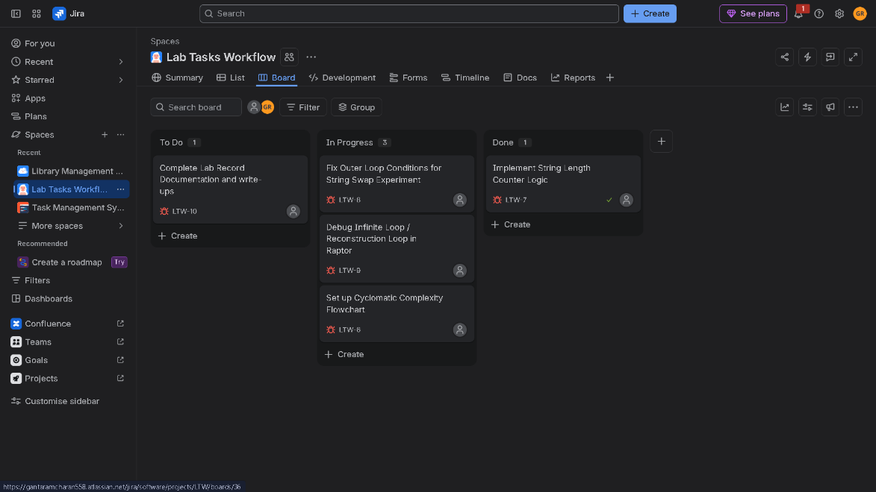
- Re-render: Refresh the UI layout to reflect the updated task positions across columns.
Screen shots:-

Result
- Result: Successfully simulated a visual task management workflow where tasks dynamically transition across execution stages in real time.
---------------------------------------------------------------------------------------------------------------
2) Create a Scrum Project in Jira.
● Add a backlog with at least 5 items (e.g., "Create user registration page", "Develop API for login").
● Prioritize the backlog and create a 1-week sprint.
● Move backlog items into the sprint and start the sprint.
● Finally show the Screenshot of the sprint board at the start and end of the sprint.
Aim
To setup a Scrum project in Jira, manage a prioritized backlog of tasks, execute a 1-week sprint lifecycle, and observe task progression on the active sprint board from start to completion.
Algorithm
- Project Setup: Create a new Scrum project template in Jira (e.g., User Auth System).
- Backlog Creation: Add 5 user stories/tasks (SCRUM-1 to SCRUM-5) to the Product Backlog and assign priority levels.
- Sprint Planning: Create a 1-week Sprint, drag the 5 prioritized backlog items into it, and define a Sprint Goal.
- Start Sprint: Click Start Sprint to transition items to the Active Sprint Board under the TO DO column.
- Workflow Execution: Drag tasks dynamically across workflow states (TO DO $→$ IN PROGRESS $→$ DONE) throughout the 1-week timeline.
- Complete Sprint: Verify all cards reach DONE status and complete the sprint cycle.
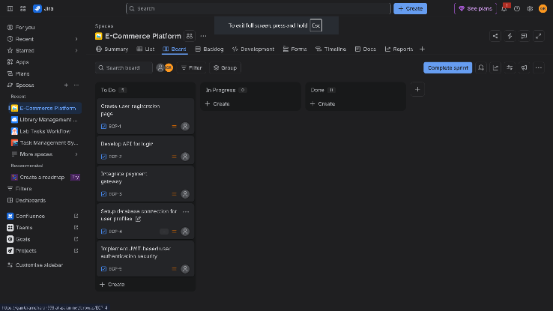
Screen shots:-

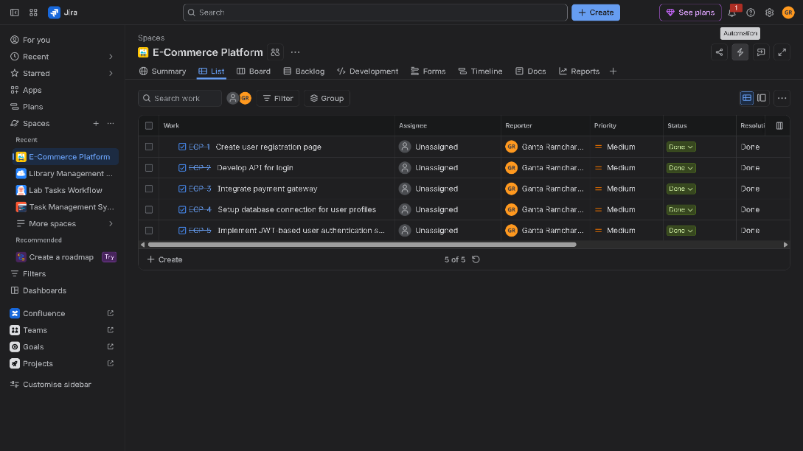

Result
- Initial Board State: All 5 prioritized user stories sit in the TO DO column when the sprint commences.
- Final Board State: All tasks successfully transition to DONE by the end of the 1-week sprint lifecycle, fulfilling the sprint goal.
3)Link Jira tasks with Confluence to streamline task tracking and progress monitoring for the Library Management System development. ● Create a new page in Confluence titled "Library Management System Project Overview." ● Embed at least 5 Jira issues related to the development of the Library Management System (e.g., tasks from the sprint like "Develop book search functionality," "Create user login page," etc.). ● Use the Jira macro to display issues with status (e.g., "To Do," "In Progress," "Done"). ● Add a progress bar in the Confluence page to visually track the completion of each embedded Jira task (e.g., percentage of tasks completed in the sprint). ● Submit a screenshot of the Confluence page showing the embedded Jira tasks and the progress bar.
Aim
To link Jira tasks with a Confluence page for a Library Management System, using the Jira macro to display live issue statuses and embed a progress bar to monitor sprint completion.
Algorithm
- Create Page: In Confluence, create a new document titled "Library Management System Project Overview."
- Embed Jira Macro: Insert the Jira Issues Macro (/jira) to fetch and display 5 key project tasks:
  - Develop book search functionality
  - Create user login page
  - Implement book issue/return API
  - Design database schema for catalog
  - Set up fine calculation system
- Configure Status Fields: Display task attributes including Key, Summary, Assignee, and Status (To Do, In Progress, Done).
- Insert Progress Visualizer: Add a Jira Chart or Status Macro progress bar to track overall completion percentage (e.g., $60\%$ completed).
- Publish & Review: Save and publish the Confluence page to provide stakeholders with real-time, synchronized visibility
Screen Shots:-
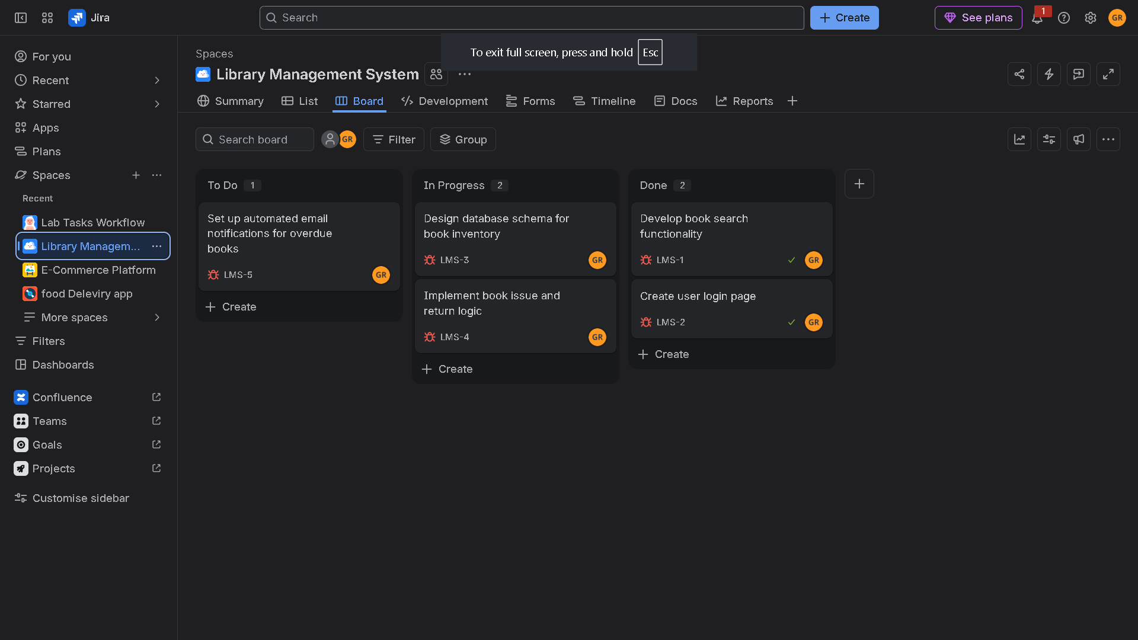
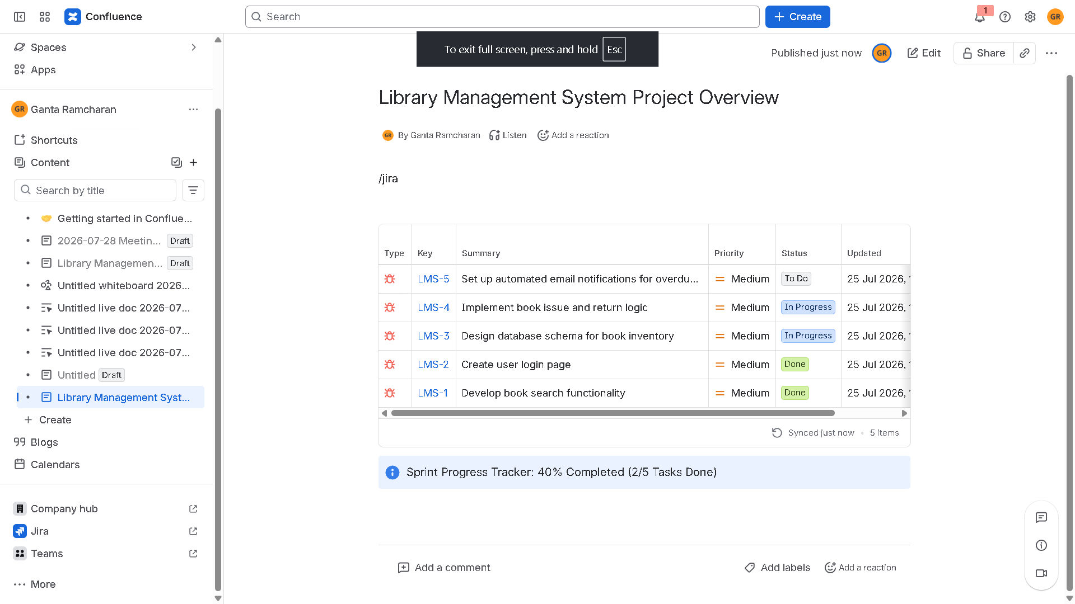

Result
- Confluence & Jira Sync: Tasks automatically sync real-time status between Jira and Confluence.
- Page Layout Representation
4)You are designing a Task Management System for a small team. The system should include the following features: 1. User Login and Role Assignment 2. Task Creation and Assignment 3. Task Prioritization and Deadlines 4. Progress Tracking and Reporting Prioritize these requirements using the MoSCoW and Kano models in Jira.
Aim
To design a Task Management System for a small team and prioritize its core features—User Authentication, Task Management, Prioritization/Deadlines, and Progress Tracking—using the MoSCoW and Kano frameworks configured within Jira.
Algorithm
- Requirement Mapping: Analyze the 4 system features and map each to its corresponding MoSCoW priority (Must have, Should have, Could have, Won't have) and Kano Model category (Basic/Must-be, Performance, Excitement, Indifferent).
- Jira Custom Fields Configuration:
  - Navigate to Jira Settings $→$ Issues $→$ Custom fields.
  - Add two select-list custom fields: MoSCoW Priority and Kano Category.
- Backlog Population: Create Jira issues for each feature and assign the corresponding MoSCoW and Kano values.
- Jira Board Setup: Configure the Jira backlog/board view or quick filters to group, filter, and track tasks according to their priority classifications.
- Review & Baseline: Validate the prioritized backlog with stakeholders to align team execution focus.
Screen Shots:-
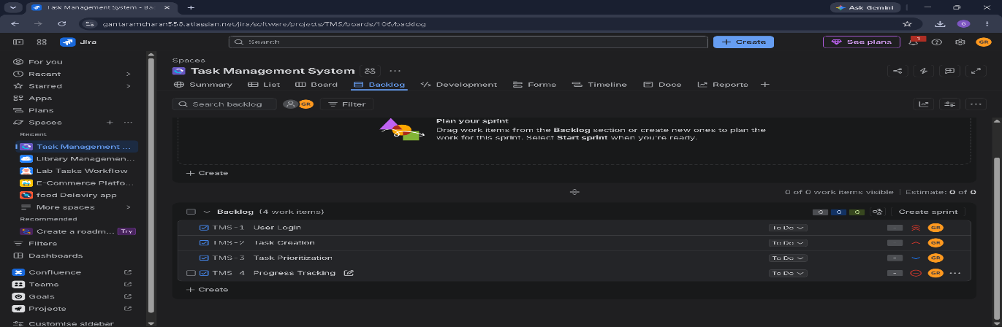
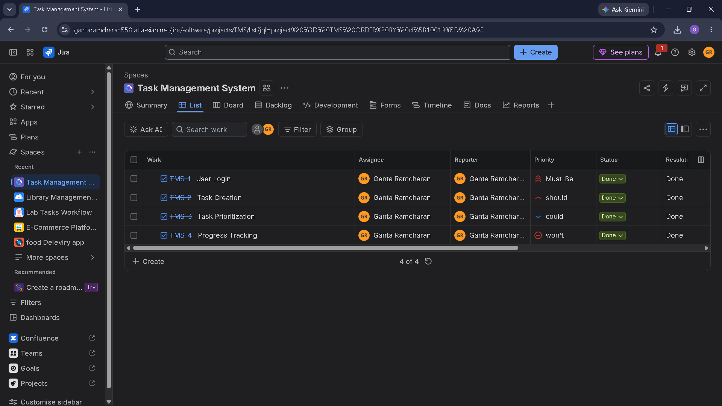
Result
- Prioritized Jira Backlog Structure:
5)You are tasked with developing an Online Learning Platform. The platform should include the following functionalities: 1. Course Enrollment and Registration 2. Video Lecture Streaming 3. Interactive Quizzes and Assignments 4. Progress Tracking Dashboard 5. Peer-to-Peer Discussion Forums 6. Certificate Generation Use Jira to categorize and prioritize these requirements using MoSCoW and Kano techniques.
Aim
To categorize and prioritize the six core features of an Online Learning Platform using MoSCoW and Kano classification techniques in Jira to guide phased development.
Algorithm
- Feature Evaluation: Analyze all six system requirements against market expectations and technical dependencies.
- MoSCoW Mapping: Classify features into Must Have (MVP critical), Should Have (important core value), Could Have (enhancement), and Won't Have (deferred for future iterations).
- Kano Classification: Assign Kano categories (Basic/Must-be, Performance, Excitement/Delighter) based on user satisfaction impact.
- Jira Custom Field Integration: Create custom dropdown fields in Jira (MoSCoW Priority and Kano Category) and populate the issues.
- Backlog Structuring: Group issues by MoSCoW priorities to form release sprints (Sprint 1 for Must Haves, Sprint 2 for Should Haves).
Screen Shots:-
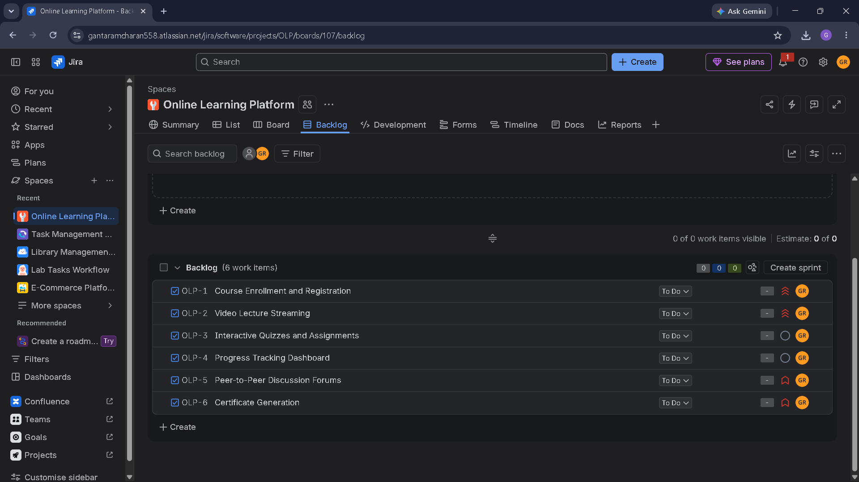
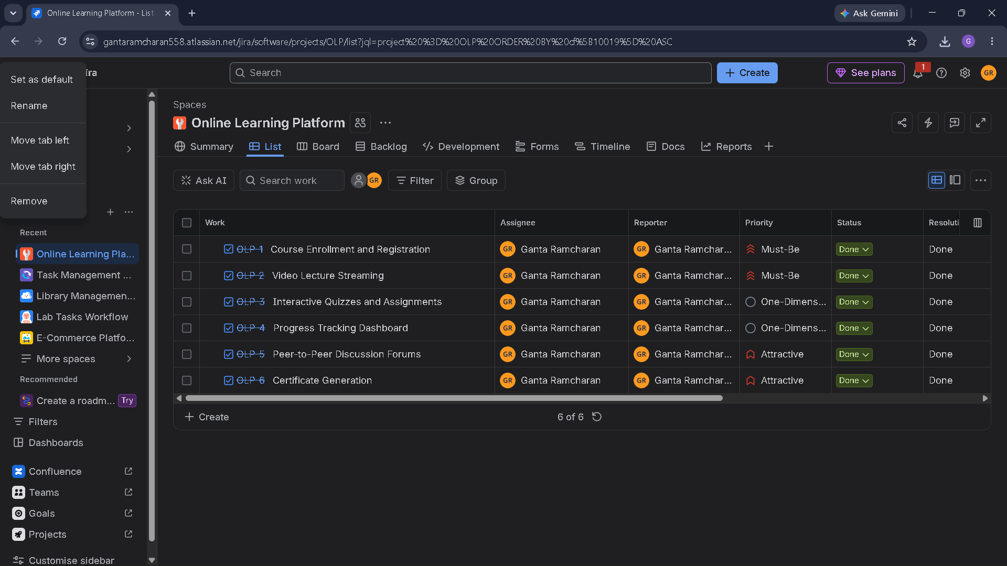
Result
- Structured Jira Backlog View

